**Software Engineering Department**

**Course Name: CMPE272– Enterprise Software Platforms**

Group Name: Team – G

Group Members: Vibhava Rayala, Nirupama Janapati, Pragati Sahu, Varsha Kollu.

Instructor: Andrew Bond

Lab Assignment #4: Building Client application that implements the twitter REST API

**Abstract:**

Twitter is an online social networking service that enables users to send and read short 140- characters messages called "tweets". Third-party Twitter applications are required to use [OAuth](https://en.wikipedia.org/wiki/OAuth), an authentication method that does not require users to enter their password into the authenticating application. Previously, the OAuth authentication method was optional, it is now compulsory and the user-name/password authentication method has been made redundant and is no longer functional. In this assignment, we build a client application that implements 8 API’s of twitter using OAuth. We have created a web application where the user logins onto a JSP (Java Server Page), which in-turn makes him connect to java, the java code checks and authenticates if the user is valid or not by validating the OAuth, If the OAuth gets validated correctly, the user gets connected to JSP through Java, and it invokes the twitter API’s, and displays the contents accordingly. The API’s implemented in this application, display the number of followers, the people we are following, tweets, and retweets etc. The Web application uses Java Server page to get connected to java, the content is displayed on Java server page, and the language used to build this web application is Java.

**Unified Modeling Language (UML):**

The Unified Modeling Language (UML) is a general-purpose, developmental, modeling language in the field of software engineering that is intended to provide a standard way to visualize the design of a system.

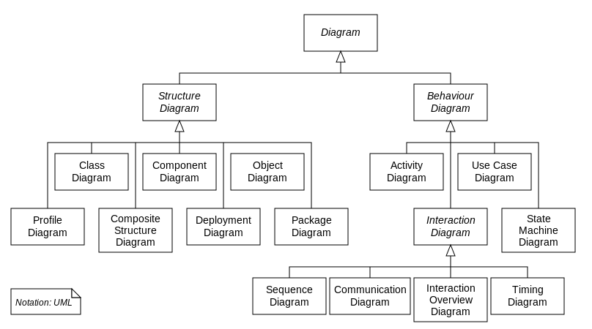

**Modules:**

Vibhava Rayala: 2 API’s Implementation, OAuth Implementation, Documentation, Unit Testing.

Nirupama Janapati: OAuth Implementation, 2 API’s Implementation, GUI Design, Deployment and Unit testing.

Pragati Sahu: 2 API’s implementation, Documentation, UML Design & Unit Testing.

Varsha Kollu: 2 API’s implementation, Documentation, UML Design & Unit Testing.

**Use Case:**

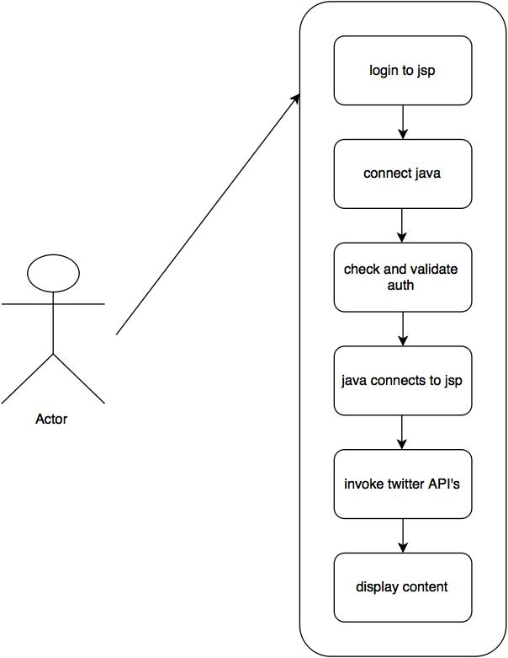

**Activity Diagram:**

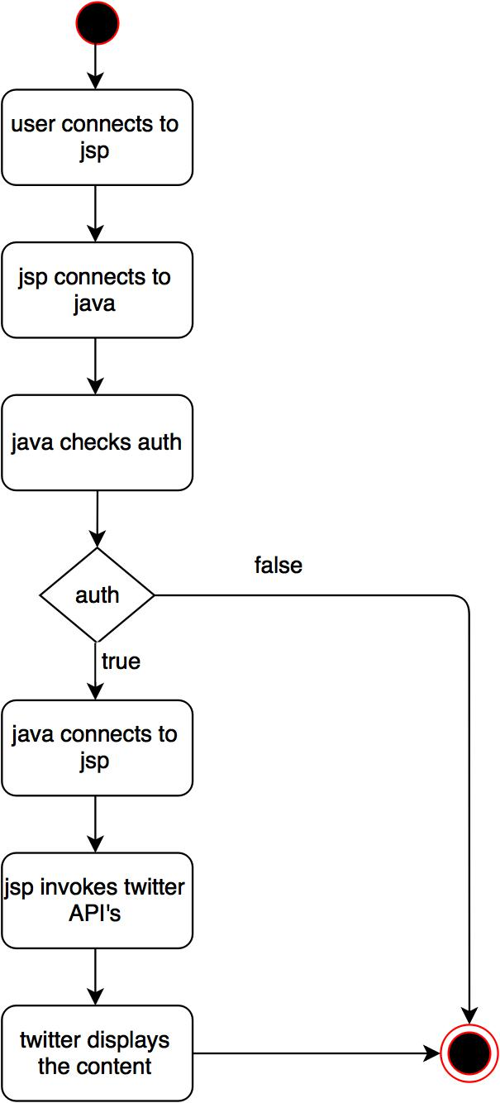

**Collaboration Diagram:**

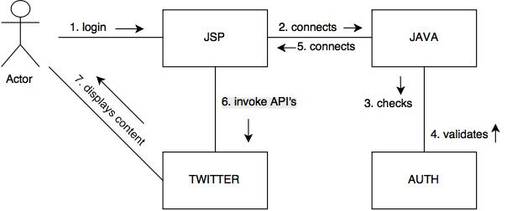

**Sequence Diagram:**

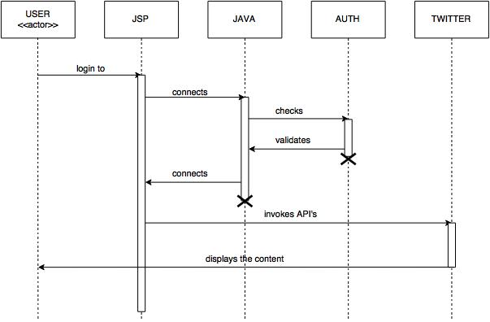

**State Chart Digaram:**

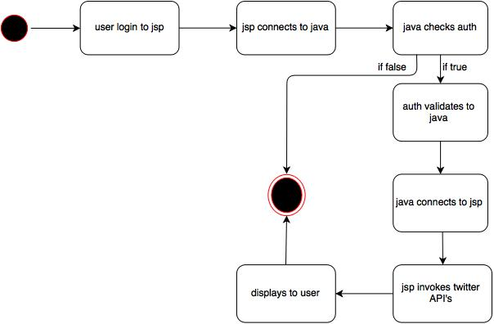

**Testing:**

Testing involves a series of different tests whose primary purpose is to fully exercise the computer based system. Although each test has a different purpose, all work should verify that all system element have been properly integrated and performed allocated function.

**Unit Testing:**

All modules were tested individually as soon as they were completed and were checked for their correct functionality. The entire module is tested individually for their functionality.

|  |  |  |
| --- | --- | --- |
| **S No.** | **Objective** | **Expected result** |
| 1 | To Test if the page is loaded correctly | The correct page is loaded with required details. |
| 2 | To Test if the page is loaded correctly | An error message must be displayed (You are not a authorised user) |
| 3 | To Test the User Functionality On Click of Authorise App Button | No Error, Redirect to the next page |
| 4 | To Test the User Functionality On Click of Authorise App button | A Message must be displayed ( Data Not correctly loaded) |
| 5 | To test the user functionality on click of the get my last 10 tweets | No Error, redirect to the page which has the 10 tweets |
| 6 | To test the user functionality on click of the get my followers | No Error, On successful retrieval, redirect to the page which has the 10 tweets |
| 7 | To test the user functionality on click of the get my friends | No Error, On Successful Retrieval redirect to the page which gets all the friends |
| 8 | To test the user functionality on click of the get following | No Error, On Successful Retrieval redirect to the page which gets all the people who are following |
| 9 | To test the user functionality on click of post tweets | No Error, On Successful Retrieval redirect to the page where we can post tweets which gets updated into my actual twitter account |
| 10 | To test the user functionality on click of search tweets | No Error, On Successful Retrieval redirect to the page where we can search tweets. |